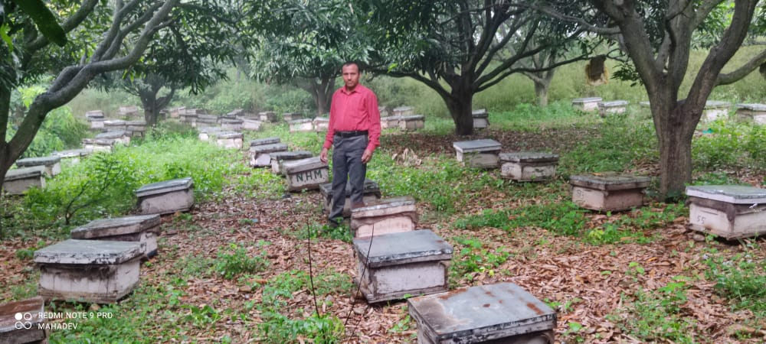

SUCCESS STORY OF BEEKEEPER

HARI KRISHAN
S/O GIAN CHAND
R/O KOSSAR
TEHSIL CHENANI
DISTRICT UDHAMPUR
✆9906908571

Success Story of Beekeeper
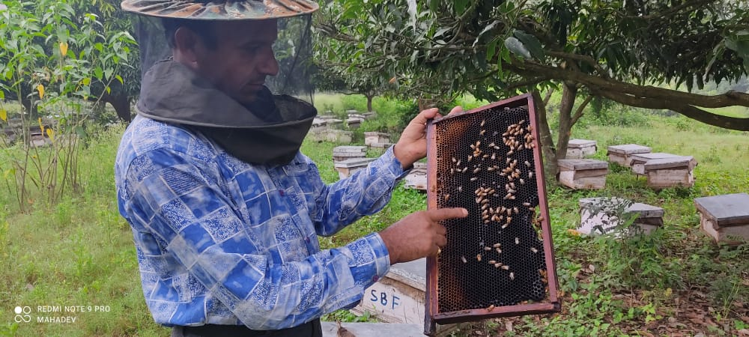
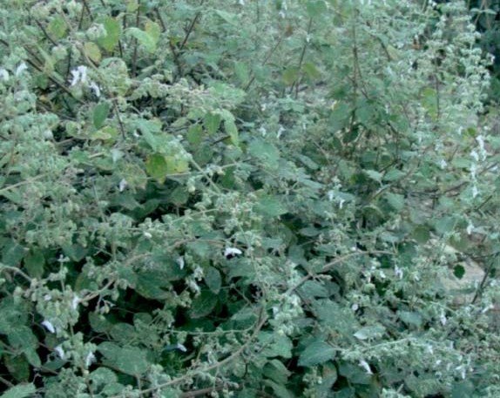
In rural areas of Udhampur District, the farmers are having very small land holdings and generally go for cultivation of cereal crops which is insufficient to run their families. In order to meet their financial requirements, they resort to migration to cities in search of work and most of them work as labour.
With the intervention of Department of Agriculture during field visits and awareness camps under different schemes farmers are guided about the different schemes being run by the department. Taking cue from these initiatives of department some farmers get motivated to adopt new interventions to increase their income.
Mr. HariKrishan S/O Gian Chand R/O Village Kossar who was cultivating cereal crops (maize & wheat) on his farm which was not sufficient to support his family and was working as a helper with a beekeeper to support his family income. As he was working as helper with a beekeeper and was having some basic knowledge about beekeeping.
During a Kissan Mela at Sudhmahadev in 1992 he visited a stall of Apiculture Development Scheme and has shown his interest to start a bee farm of his own. He was guided by the staff of Apiculture Development Scheme about the incentives being provided by the department for establishing bee farm.
Keeping in view his keenness to start bee farm he was imparted the technical knowhow about beekeeping by the Staff of Apiculture Development Scheme in training sessions at departmental centres. After obtaining mandatory knowledge about beekeeping, he was selected for incentive on 25 Nos of bee colonies from Apiculture Development Scheme in 1992. With his hard work and dedication to grow in the bee keeping enterprise, he multiplied the colonies manifolds under the technical guidance of Apiculture Development Scheme in the successive years and reinvested his profits to expand his farm.
At present he is having 1270 Nos of bee colonies from which he harvested 260 Qtls. of honey during FY 2020-21 and earned a net profit of 18.80 lacs. He has also set up a plant for making of comb foundation sheets which not only to fulfil the requirements of comb foundation sheets of his farm but he also sells them to other beekeepers of the area. He also sells bee colonies too to the beekeepers, which also generate extra income to his savings which has raised his socio-economic conditions to a great extent.
To increase the honey production, he keeps migrating his bee farm from one state to another (from Sudhmahadev to Rajasthan, Haryana, Punjab, Kashmir and Himachal Pradesh) as per the availability of beeflora thus also increasing the productivity of crops in that particular area.

He produces different types of honey among them Mustard Honey, Kikar Honey, Ber Honey, Sulai Honey, Litchi Honey are prominent which fetches more price in the market. He is marketing his honey under the trade name “M/S Mahadev Honey Bee Apiary, Sudhmahadev”.

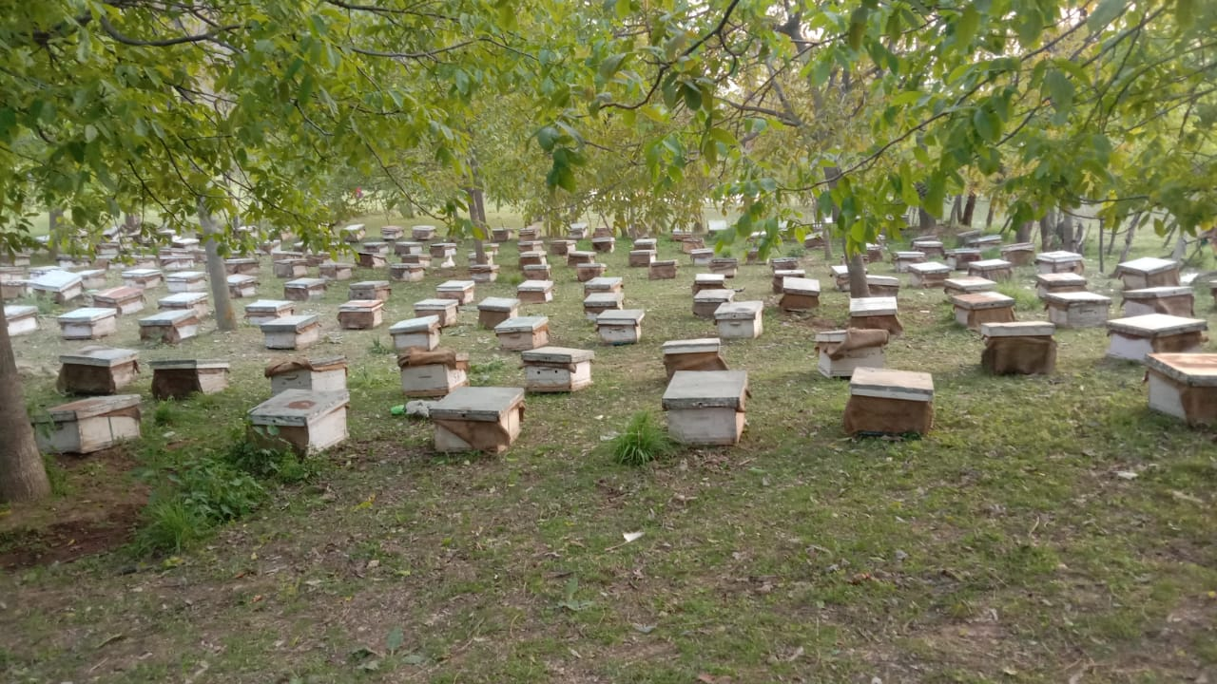
IMPACT:
He has provided employment to 6 unemployed youths at his farm and pays monthly salary of Rs 10000 each by virtue of which they are enabled to earn bread and butter for their families. Thus, he also contributes to the society by giving employment to unemployed youth through a sustainable and environment friendly enterprise besides his personal gains.
His remarkable success in the field of Apiculture has attracted the attention of many young educated youth of Sudhmahadev area towards beekeeping.
Taking view of his phenomenal success in beekeeping he is awarded and honored at different forums.
As “Best Farmer” in beekeeping under ATMA during the year 2020-21 by Department of Agriculture.
Empaneled as a “Bee Breeder” by Department of Agriculture for the supply of Bee colonies to the potential beekeepers.
Awarded “Letter of Honour” by Swadeshi Jagran Manch for his contribution as Income and employment provider.
As “Progressive Beekeeper” at “Northern India Regional Agriculture Fair-2021 at SKUAST-J on 10th of Oct-2021 for his achievements as a promising Beekeeper of Udhampur.

Present Status
Bee Colonies during 2020-21 | 1270 Nos
Total Expenditure | 15.0 (lakhs) for artificial feeding, migration, maintenance, chemicals, payment of wages to staff
Total Production | 260.0 Qtls
Total Earning | 33.80 lakhs
Cost benefit ratio | 1:2.25

